**Maize Analytics**

Turning Explanations On and Off

**Turning Explanations On and Off:**

Users can view a list of explanations the system found in your organization’s data by clicking the gears icon. With Maize-supervised machine-learning, you can turn explanations “on” or “off” to enforce future audits. **You can also change which explanations appear as filters vs. flags**. Active explanations will be applied to future audits. Inactive explanations will not. Check that active explanations are consistent with your organization’s policies.

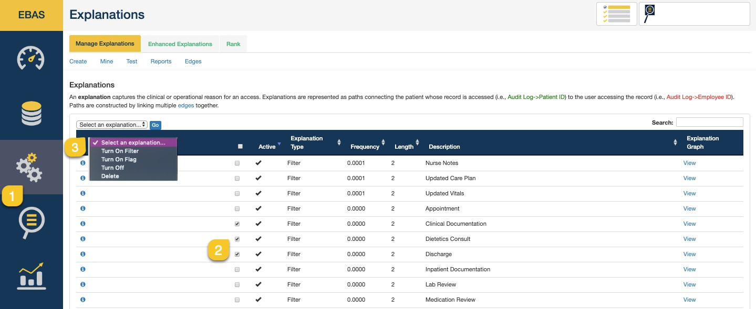

Below is a walkthru of changing the explanation type of an explanation from a flag to a filter.

Enhanced Explanalions Rank Reporls Eo;ies

AA e1 anatlon caplures theciinicaloroperat nalreas0/111'a1naccess,Exptanati011s arerepresentedaspa s cOMecfnglhe pat nt misereooril isaccessed j.e.,Audi!Log-,Pallent ID)to e user aooessingtherecord j.e,,AoortLng-,EmployeIeD),Paths *ate* conatructed bylinkingmultipleedges toge er.

I Setect anexpM11li011:,.,I

Search:

I Active * Explanallon Type Frequency * Lenglh * Descriptlon * Ex anallon Graph

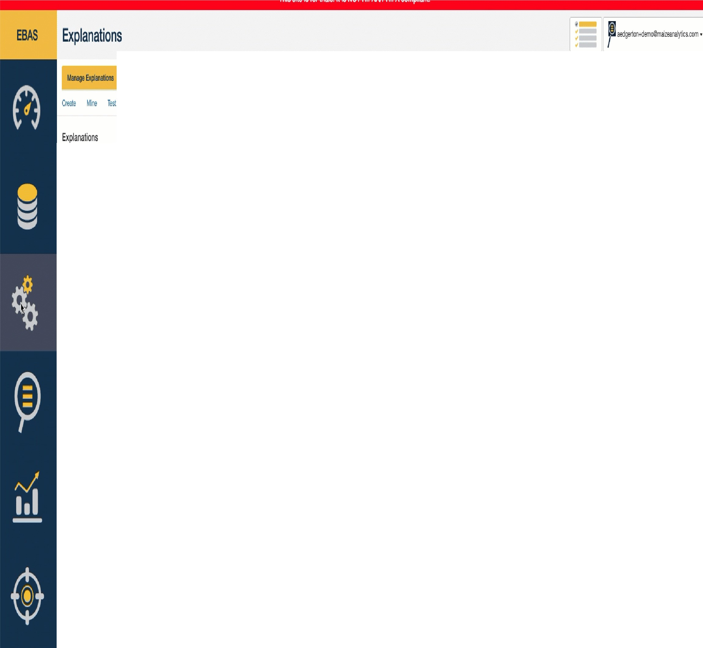

* **ii** ' Filler O.lllflf NurseNotes *View*
* **ii** ' Filter O.llllll UpdaledCarePlan *View*
* **ii** ' Filter 0.0001 UpdaledWals *View*
* **ii** ' Filler O.Olllfl Appointment *View*
* **il** ' Filter O.Olllll OinicaDooumenfatbn *View*
* **li** ' Filter O.Olllfl eletlcsConstJII *View*
* **il** ' Filler O.Olllfl !Clwge *View*
* **il** ' Filter O.Olllll lnpatienlDoourrenlation *View*
* **ii** ' Filter O.Olllfl LabReview *View*
* **ii** ' Filler O,lllflO Med alionRe\iew *View*
* **ii** ' Filter O.lllflO Order w *View*
* **ii** ' Filter O.lllflO OrderMedicalioo *View*
* **ii** ' Filler O,lllflO PalientLev!DIooumenls *View*
* **il** ' Filter O.lllflO Phanmacy sl *View*
* ' Filter O.lllflO Surge,y *View*
* **ii** ' Filler O.Olllfl LMngErwronmenUt pdate *VlflW*
* **il** ' Filter O.Olllll Med alion *VlflW*
* ' Filter O.Olllfl *V ls VlflW*
* **il** ' Filter O.Olllfl WillllilCarePertormed *View*